Communiqué

March 2013 meeting of the Aboriginal and Torres Strait Islander
Health Practice Board of Australia
Introduction
The Aboriginal and Torres Strait Islander Health Practice Board of Australia (the Board) works in partnership with the Australian Health Practitioner Regulation Agency (AHPRA) to implement the National Registration and Accreditation Scheme (the National Scheme).
Details on individual Board members can be found on the Board’s website.
Registration
Current registration figures
By the end of February 2013 there were 276 registered Aboriginal and Torres Strait Islander health practitioners throughout Australia. This is 0.7 per cent increase from the previous month, which had
274 registrants. The increase came from two additional registered health practitioners from the Northern Territory.
Overwhelmingly, registrants practice out of the Northern Territory, with 222 practitioners nominating the NT as their principle place of practice (PPP). This represents 80.4 per cent of all registrants of this profession. The number of registered Aboriginal and Torres Strait Islander health practitioners in other states and territories is illustrated in the graph below. Queensland hosts the second largest registrant base for this profession, with 10% of practitioners nominating this state as their principal place of practice.
This is followed by New South Wales (five per cent), Western Australia (two per cent), and Victoria
(one per cent).
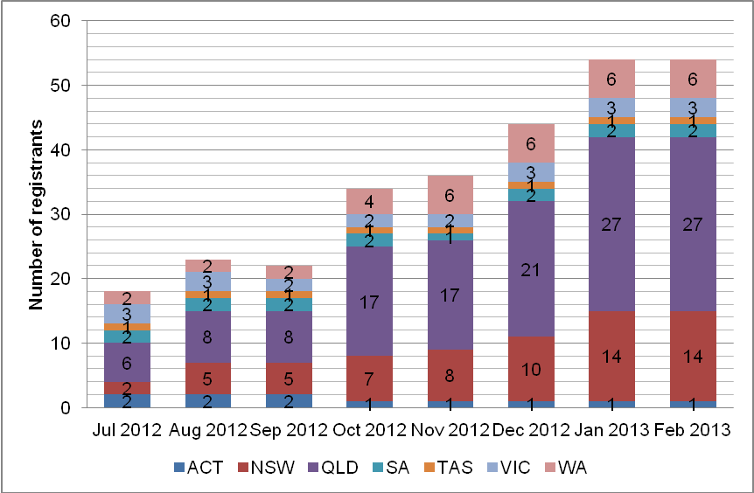

Who should be registered?
Only Aboriginal and Torres Strait Islander people who are working as Aboriginal and Torres Strait Islander health practitioners and are required by their employer to use any of the following protected titles, must be registered by law. This group also must meet the Board's registration standards in order to practise in Australia.
The protected titles are:
- Aboriginal and Torres Strait Islander health practitioner
- Aboriginal health practitioner, or
- Torres Strait Islander health practitioner.
Aboriginal and Torres Strait Islander health workers who are not required by their employer to use a protected title do not need to be registered, and can continue to work using their current titles (for example, ’sexual health worker’, or ’drug and alcohol worker’, or ’mental health worker’).
However, if an Aboriginal and Torres Strait Islander health worker’s job involves direct clinical care of patients, the Board highly recommends that they apply for registration in the interest of public safety. Registration is a way of ensuring that only health practitioners who are suitably trained and qualified to practise in a competent and ethical manner are registered.
Application forms for registration as an Aboriginal and Torres Strait Islander health practitioner are available on the Board’s website at www.atsihealthpracticeboard.gov.au/Registration/Forms.
Accreditation
The establishment and operation of the Board’s accreditation function has been identified as one of its highest priorities for 2013.
The Board is one of three that joined the National Scheme in 2012 that has decided to exercise accreditation functions through a committee of the board, as provided for under subsection 43(1)(b) of the National Law.
The four-member Accreditation Committee has only three members: Elaine Duffy (Chair), Sharon Wallace and Norma Lukies. A call for Nominations or Expressions of Interest for the fourth Committee member closed on 1 April 2013. The Board will soon undertake a formal selection process to appoint the fourth member.
The Committee has scheduled a joint meeting with the Board on 24 April in Melbourne. This meeting will enable the Board and the Committee to monitor and evaluate the agreed timelines for key milestones of this priority function.
Updates on key milestones will be published in the next Communiqué.
Other Board activities
Strategic statement and work plan to 2014
The Board approved its strategic statement and work plan to 2014. Once the details have been finalised, the statement and work plan will be published on the Board’s website.
Restructure of Board committees
The Board has established three committees: two with delegated responsibilities derived from the Board – the Registration and Notifications Committee and the Communications Committee; and one with statutory responsibilities derived from the National Law – the Accreditation Committee.
To improve efficient decision making and effectiveness of its two committees with delegated responsibilities, the Board resolved to reduce the size of its Registration and Notifications Committee and renew the functions of its Communications Committee.
Each committee will now have four Board members and the Board Chair as members. The Registration and Notifications Committee will continue with its current role of reviewing, assessing and determining applications for registration and renewal, and decisions about notifications (i.e. complaints). The Communications Committee will undertake new responsibilities derived from the Board’s newly adopted strategic statement and work plan, i.e. to monitor and evaluate feedback from stakeholders on the Board’s regulatory function, and recommend approaches to consult, promote, engage, and collaborate with stakeholders.
Board vacancy
The vacancy on the Board for a registered Aboriginal and Torres Strait Islander health practitioner from Queensland is expected to be considered by the Australian Health Workforce Ministerial Council by the end of April. Once finalised, the Board will formally announce the appointment through this Communiqué.
Current consultations
From time to time the Board seeks feedback from practitioners, members of the public and other stakeholders on proposed standards, guidelines, codes and policies. We encourage your active feedback on these proposals, so please keep a watch of the consultation section of Board’s website at www.atsihealthpracticeboard.gov.au/News/Consultations. Past consultations are also accessible from this section.
Projects
A Unique and Valued Profession: Aboriginal and Torres Strait Islander Health Workers
Two Board members, Peter Pangquee (Board Chair) and Jenny Poelina appeared on a live interactive panel discussion broadcast on the Rural Health Education Foundation’s satellite network on 26 February 2013. The panel discussion can be viewed on Rural Health Education Foundation’s website.
The panel discussion is part of a multimedia package project aiming to improve non-Aboriginal health professionals, employers and managers’ understanding of and respect for the Aboriginal and Torres Strait Islander health worker role and to foster improved inter-professional relationships and increase the integration of Aboriginal and Torres Strait Islander health workers within the primary health care team.
The free multimedia DVD package consists of a half hour documentary, the live and interactive panel discussion, a learning guide and filmed segments and interviews. Orders can be made from the Rural Health Education Foundation’s website.
The Board recommends this multimedia package to Aboriginal and Torres Strait Islander health practitioners seeking resources to promote the importance of their role to fellow health practitioners in a primary health care setting.
Peter Pangquee
Chairperson

29 April 2013

