Communiqué

December 2012 meeting of the Aboriginal and Torres Strait Islander
Health Practice Board of Australia
Introduction
The Aboriginal and Torres Strait Islander Health Practice Board of Australia (the Board) works in partnership with the Australian Health Practitioner Regulation Agency (AHPRA) to implement the National Registration and Accreditation Scheme (the National Scheme).
Registration
By the end of December there were 298 registered Aboriginal and Torres Strait Islander health practitioners throughout Australia. This is a 2.4 per cent increase from the previous month.
Overwhelmingly, registrants practice out of the Northern Territory, with 254 practitioners nominating the NT as their principle place of practice (PPP). This represents 85.2 per cent of all registrants of this profession.
The number of registered Aboriginal and Torres Strait Islander health practitioners in other states and territories is illustrated in the graph below. With 7 per cent, identifying Queensland as their PPP, it hosts the second largest registrant base for this profession. This is followed by New South Wales (3.4 per cent), Western Australia (2 per cent), and Victoria (1 per cent).
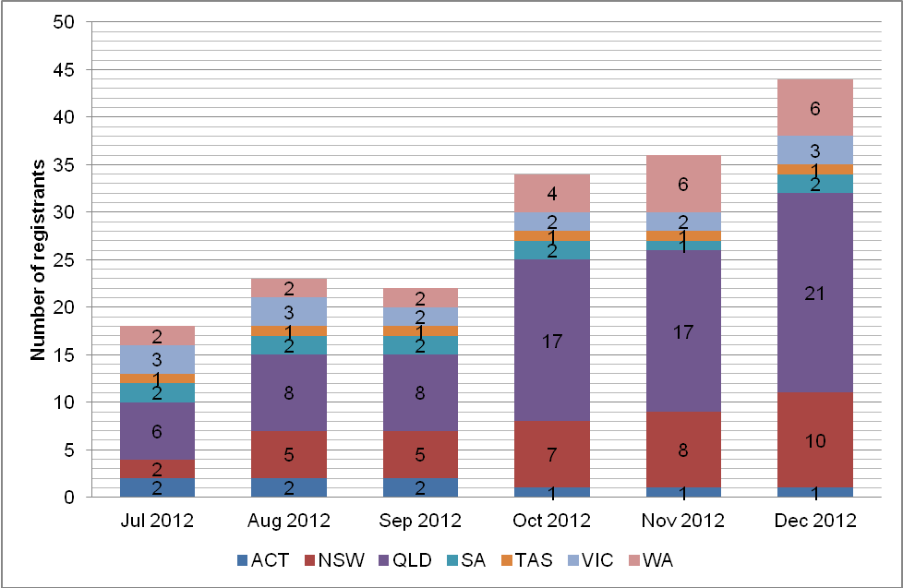
Who should be registered?
Only Aboriginal and Torres Strait Islander people who are working as Aboriginal and Torres Strait Islander health practitioners and are required by their employer to use any of the following protected titles, must be registered by law. This group also must meet the Board's registration standards, in order to practise in Australia.
The protected titles are:
- Aboriginal and Torres Strait Islander health practitioner
- Aboriginal health practitioner, or
- Torres Strait Islander health practitioner.
Aboriginal and Torres Strait Islander health workers who are not required by their employer to use the protected titles don’t need to be registered, and can continue to work using their current titles (for example, ’sexual health worker’, or ’drug and alcohol worker’, or ’mental health worker’).
However, if an Aboriginal and Torres Strait Islander health worker’s job involves direct clinical care of patients, the Board highly recommends that they apply for registration in the interest of public safety. Registration is a way of ensuring that only health practitioners who are suitably trained and qualified to practise in a competent and ethical manner are registered.
Application forms for registration as an Aboriginal and Torres Strait Islander health practitioner are available on the Board’s website at www.atsihealthpracticeboard.gov.au/Registration/Forms.
Accreditation
The Board is one of three of boards that joined the National Scheme in 2012 that has decided to exercise accreditation functions through a committee of the board, as provided for under subsection 43(1)(b) of the National Law.
The Accreditation Committee held its first meeting on 29 November 2012 and will meet again on 27 February 2013. At this stage the committee has three members: Elaine Duffy (Chair), Sharon Wallace and Norma Lukies.
There is a vacancy for a registered Aboriginal and Torres Strait Islander health practitioner, which is in the process of being re-advertised.
AHPRA’s Accreditation Unit has been working on resources to help the committee develop accreditation standards and processes, as well as a new accreditation cycle, as quickly as possible. These resources include comparing accreditation standards and processes, including for the Vocational Education and Training (VET) sector qualifications, and documents which the committee can use as a starting point for developing its own standards and processes.
The committee is also working on:
- the transitional arrangements for existing programs of study
- the ongoing arrangements for monitoring programs of study
- a communication strategy, and
- posting information about the committee’s functions and work online.
Once the accreditation standards have been drafted, they will be released for consultation by the committee and commitment will be sought from practitioners, the community and other stakeholders.
Regular updates will be published online and in future communiqués.
Other Board activities
Board vacancy
There is a vacancy on the Board for a registered Aboriginal and Torres Strait Islander health practitioner from Queensland. AHPRA has sought applications by advertising expressions of interest and working closely with stakeholders in Queensland to fill this vacancy.
Current consultations
The Board is seeking feedback from practitioners, members of the public and other stakeholders on which roles should be regulated and what qualifications are appropriate for registration. This discussion paper can be found at www.atsihealthpracticeboard.gov.au/News/Past-Consultations. We encourage your feedback on the questions raised in the discussion paper by 22 February 2013.
The discussion paper is the result of the Board’s work on the Benchmarking and risk assessment project, see below.
Projects
Benchmarking and risk assessment project
Health Workforce Australia (HWA) has funded AHPRA (on behalf of the Board) to undertake a two-phase project on:
- registration qualification benchmarking, and
- safety risk assessment.
HWA provides a contextual overview of this project on its website at www.hwa.gov.au/work-programs/workforce-innovation-and-reform/atsihw/benchmarking-risk-assessment.
The first phase of this project has been completed. The second phase, which is in progress, will involve assessing the following.
- Which Aboriginal and Torres Strait Islander primary health care worker roles should be regulated based on an assessment of risk to the public?
- What qualifications should be regarded as the appropriate educational preparation for the registration of these practitioners?
Other projects
The Board is represented on several HWA funded projects, including:
- The development of the Aboriginal and Torres Strait Islander Health Worker Multimedia Resource Package. For more information, go to www.hwa.gov.au/work-programs/workforce-innovation-and-reform/atsihw/multimedia-resource.
- Review of the Health Training Package, in particular the Aboriginal and Torres Strait Islander Primary Health Care qualifications. For more information, go to www.cshisc.com.au/index.php?option=com_content&task=view&id=975&Itemid=1008&limit=1&limitstart=2.
- Aboriginal and Torres Strait Health Practitioner Clinical Logbook review and update. For more information, go to www.hwa.gov.au/work-programs/workforce-innovation-and-reform/atsihw/log-books.
Peter Pangquee
Chairperson

8 March 2013

