Aboriginal and Torres Strait Islander Data: December 2012

Published January 2013
Introduction
The functions of the Aboriginal and Torres Strait Islander Health Practice Board of Australia include:
- registering the Aboriginal and Torres Strait Islander practitioners and students
- developing standards, codes and guidelines for the Aboriginal and Torres Strait Islander health practice profession
- handling notifications, complaints, investigations and disciplinary hearings
- approving accreditation standards and accredited courses of study.

The Board’s functions are supported by Australian Health Practitioner Regulation Agency (AHPRA). For information about legislation governing our operations see AHPRA's Legislation & Publications at www.ahpra.gov.au/Legislation-and-Publications.aspx

The Board has analysed its registration data and produced a number of statistical breakdowns about registrants to share with the profession and community. The Board shares these breakdowns regularly.

For more information on Aboriginal and Torres Strait Islander Health Practitioners registration, please see the Board’s website: www.atsihealthpracticeboard.gov.au/Registration.aspx

Index of Tables
Aboriginal and Torres Strait Islander Health Practitioners: State and territory by registration type 2
% By state and territory 2
Aboriginal and Torres Strait Islander Health Practitioners: Age by registration type 3
% By age 3
Aboriginal and Torres Strait Islander Health Practitioners: Gender by state and territory by registration type 4

Please Note: The numbers in this report reflect the National Board’s registration data as at 31 December 2012. These statistics include approximately 36 registrants who did not renew their registration by the end of the registration renewal late period for this profession, and were removed from the register on 3 January 2013, as required by the National Law.

Aboriginal and Torres Strait Islander Health Practitioners: State and territory by registration type
State | General | Total | % By State
ACT | 1 | 1 | 0.34%
NSW | 10 | 10 | 3.36%
NT | 254 | 254 | 85.23%
QLD | 21 | 21 | 7.05%
SA | 2 | 2 | 0.67%
TAS | 1 | 1 | 0.34%
VIC | 3 | 3 | 1.01%
WA | 6 | 6 | 2.01%
Total | 298 | 298

% By state and territory
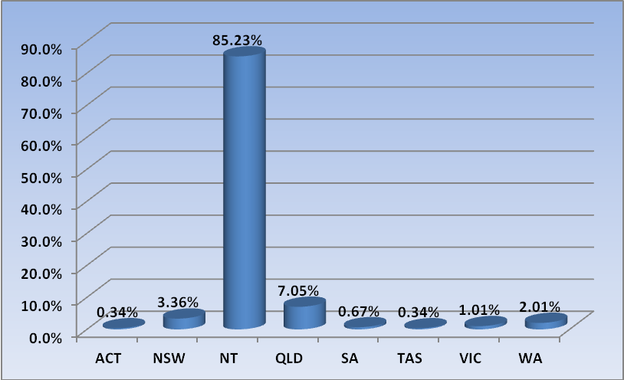

Aboriginal and Torres Strait Islander Health Practitioners: Age by registration type
Age Group | General | Total | % By Age Group
21 - 25 | 5 | 5 | 1.68%
26 - 30 | 20 | 20 | 6.71%
31 - 35 | 20 | 20 | 6.71%
36 - 40 | 51 | 51 | 17.11%
41 - 45 | 57 | 57 | 19.13%
46 - 50 | 53 | 53 | 17.79%
51 - 55 | 39 | 39 | 13.09%
56 - 60 | 25 | 25 | 8.39%
61 - 65 | 18 | 18 | 6.04%
66 - 70 | 7 | 7 | 2.35%
71 - 75 | 1 | 1 | 0.34%
76 - 80 | 1 | 1 | 0.34%
Not Stated | 1 | 1 | 0.34%
Total | 298 | 298

% By age
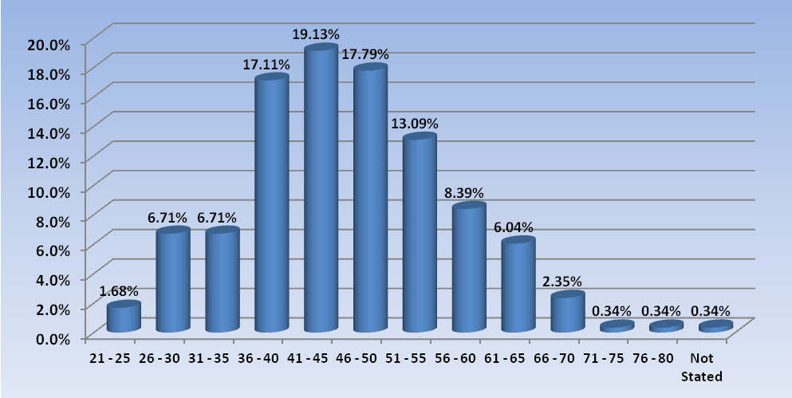

Aboriginal and Torres Strait Islander Health Practitioners: Gender by state and territory by registration type
Sex | State | General | Total Count | % By Sex By State
Female | ACT | 1 | 1 | 0.34%
Female | NSW | 8 | 8 | 2.68%
Female | NT | 185 | 185 | 62.08%
Female | QLD | 18 | 18 | 6.04%
Female | SA | 2 | 2 | 0.67%
Female | TAS | 1 | 1 | 0.34%
Female | VIC | 3 | 3 | 1.01%
Female | WA | 5 | 5 | 1.68%
Female | Sub total | 223 | 223 | 74.83%
Male | NSW | 2 | 2 | 0.67%
Male | NT | 69 | 69 | 23.15%
Male | QLD | 3 | 3 | 1.01%
Male | WA | 1 | 1 | 0.34%
Male | Sub total | 75 | 75 | 25.17%
Total |  | 298 | 298

