Communiqué

December 2013 meeting of the Aboriginal and Torres Strait Islander
Health Practice Board of Australia
Introduction
The Aboriginal and Torres Strait Islander Health Practice Board of Australia (the Board) works in partnership with the Australian Health Practitioner Regulation Agency (AHPRA) to implement the National Registration and Accreditation Scheme (the National Scheme). Details about individual Board members can be found on the Board’s website.
The Board meets every two months and its last bimonthly meeting was held on 19 December 2013. A stakeholder forum on registration of Aboriginal and Torres Strait Islander health practitioners was held the day before the Board meeting.
The Board also held two out-of-session meetings in November to consider specific and urgent matters:
- on 21 November the Board met to consider the accreditation standards and processes recommended by its Accreditation Committee, and
- on 29 November the Board met to consider waiving all late renewal of registration fees for 2013.
Future Board meetings for the 2013/14 financial year will be held on 26 February 2014 in Brisbane, 23 April 2014 in Perth and 25 June 2014 in Melbourne.
News
A forum on registration for Aboriginal and Torres Strait Islander health practitioners – Sydney
On 18 December, the Board held a stakeholder forum at the Aboriginal Health College at Little Bay in Sydney to promote registration for Aboriginal and Torres Strait Islander health practitioners. Over 50 health workers, employers, government officials and peak bodies attended the forum to listen to the Board Chair’s presentation on registration, meet Board members and AHPRA staff and ask questions.
An additional 60 attendees viewed the forum via an online webcast.
There were several questions asked about the registration process (for new applicants and renewing registrants), accreditation status of registered training providers, getting Medicare provider numbers, and the scope of an Aboriginal and Torres Strait Islander health practitioner. Answers to Frequently Asked Questions (FAQs) on registration and accreditation are available on the Board’s website.
The Board has scheduled future stakeholder forums as follows.
Date | City
Wednesday 26 February 2014 | Brisbane
Wednesday 23 April 2014 | Perth
Wednesday 25 June 2014 | Melbourne
Full details are available on the Board’s website . To register your interest in attending the Board’s stakeholder forums, or to request more information, contact ATSIHPBA-calendar@ahpra.gov.au.
Board decisions
Accreditation standards and processes for Aboriginal and Torres Strait Islander health practice
At an out-of-session meeting on 21 November, the Board approved the Accreditation standards for Aboriginal and Torres Strait Islander health practice in accordance with section 47(2)(a) of the National Law. The Board also endorsed Accreditation processes for Aboriginal and Torres Strait Islander health practice.
The approved accreditation standards have been published in the accreditation section of the Board’s website. You can receive updates from the Accreditation Committee by completing the online form.
Late registration renewal fees waived for 2013
At an out-of-session meeting on 29 November, the Board agreed to waive the late registration renewal fee for 2013 for any registration renewal application made by an Aboriginal and Torres Strait Islander health practitioner after the registration period ends on 30 November 2013.
New guidelines for advertising, mandatory notifications and new social media policy
The revised new guidelines and policy are expected to be published in early February 2014 for commencement in late March. Please continue to monitor the news section of the Board’s website for further updates.
Update on the Board’s proposed supervision guidelines
Please Note: The Board’s supervision guidelines are not designed for supervising trainees or students. In these circumstances, the registered training provider and work/clinical placement provider have full responsibility for the supervision of their trainees and students, including their learning and assessment.
The Board is developing guidelines for Aboriginal and Torres Strait Islander health practitioners and their supervisors. When finalised, these guidelines may be used in a range of supervision arrangements, including Aboriginal and Torres Strait Islander health practitioners who:
- are returning to practice after an absence of greater than three years
- have had a significant change to scope of practice
- have a condition or undertaking on their registration from a health, performance or conduct matter that requires supervision, and/or
- have a condition related to adequacy of qualifications on their registration.
The Board’s draft supervision guidelines were sent out to a small group of key stakeholders as part of a preliminary consultation process, which ended on 31 July 2013. After some significant delays in receiving this feedback, the Board has completed its analysis and will consider the next iteration for release for public consultation at its February 2014 meeting.
When released for public consultation in early 2014, you will find full details of the Board’s draft supervision guidelines in the consultation section of the Board’s website. Your feedback will be appreciated.
Recommended hours of mandatory work placements for its registration qualification
The Board approved the recommended hours for mandatory work placements for its registration qualification (the HLT40213 Certificate IV in Aboriginal and/or Torres Strait Islander Primary Health Care Practice) as 800 hours.
The Community Services and Health Industry Skills Council (CS&HISC) publishes key implementation advice for registered training organisations (RTOs) delivering the Board’s registration qualification. This advice is contained in Companion Volumes, which includes the Implementation guide, Learning strategies guide and Assessment strategies guide. These can be found under Training packages on the CS&HISC’s website. These guides currently refer to the recommended hours for mandatory work placements for the qualification, as per the requirement for registration as an Aboriginal and/or Torres Strait Islander Health Practitioner with the Board.
Registration
Current registration figures
The Board collects and analyses data about Aboriginal and Torres Strait Islander health practitioner registrations. The Board shares the data and analyses each quarter on its website.
The data provided is:
- state and territory by registration type
- age by registration type, and
- gender by state and territory by registration type.
In addition to the above statistics, this Communiqué provides stakeholders with an overview of specific data over a period of time.
The table below shows that by the end of November 2013 there were 322 registered Aboriginal and Torres Strait Islander health practitioners in Australia. This is a 1.9% increase from the previous month.
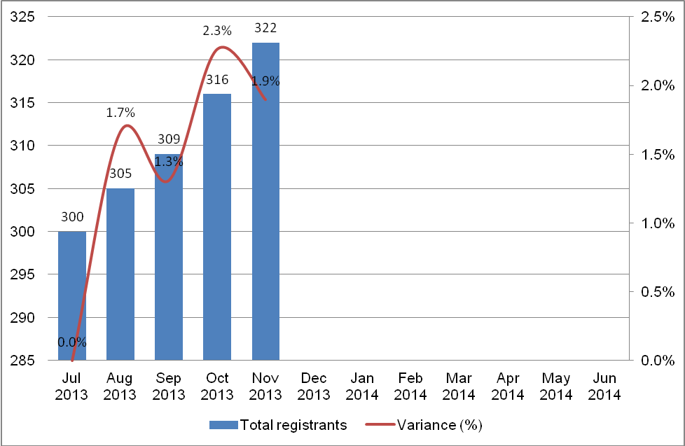
The overwhelming majority of registered Aboriginal and Torres Strait Islander health practitioners are in the Northern Territory, with 231 registrants nominating the NT as their principal place of practice (PPP). This represents 72% of the profession. This is a 1% decrease from the previous month.
As the number of the registered Aboriginal and Torres Strait Islander health practitioners grows in other states and territories, the NT’s proportion of this profession gradually declines, as illustrated in the graph below.
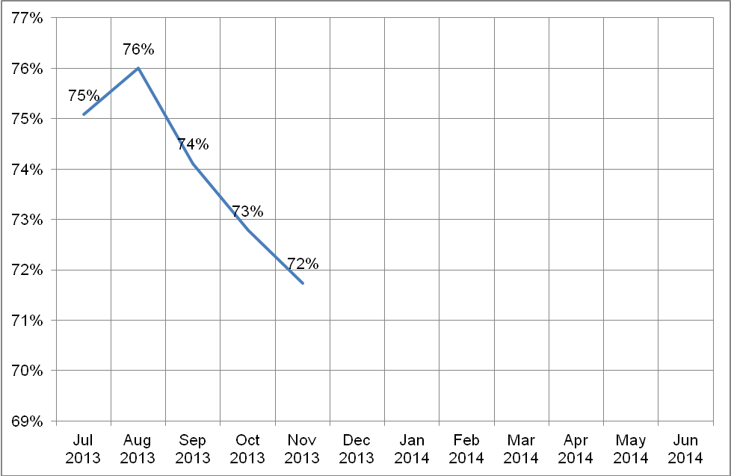
The number of registered Aboriginal and Torres Strait Islander health practitioners in other states and territories is illustrated in the graph below. As in the previous month, Queensland hosts the second largest registrant base for this profession, with 11%. This is followed by New South Wales (8%), Western Australia (3%), South Australia (2%) and Victoria (2%).

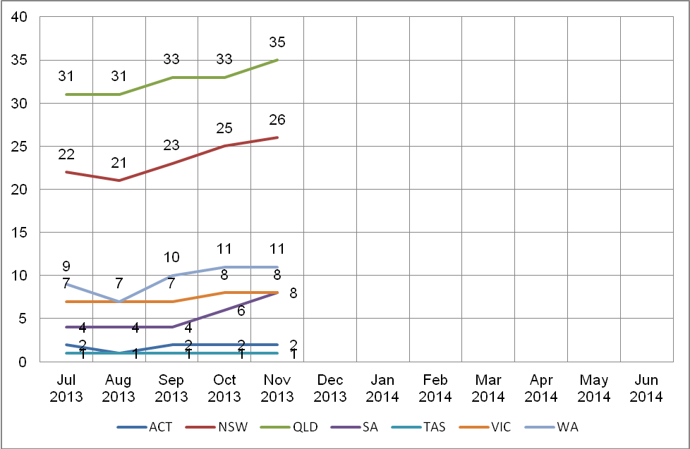
Who should be registered?
The Health Practitioner Regulation National Law, as in force in each state and territory (the National Law), requires a practitioner to be registered if they wish to, or their employer requires them to use one of the protected titles. The protected titles are:
- Aboriginal and Torres Strait Islander health practitioner
- Aboriginal health practitioner, or
- Torres Strait Islander health practitioner.
A practitioner may be required to be registered as part of their employment requirements, even if the protected title is not used.
The current wording implies that an employer must have their staff use a protected title for anyone performing the functions of an Aboriginal and Torres Strait Islander health practitioner. In fact, an employer may call a job anything they like, but if the employer requires the practitioner to hold registration as an Aboriginal and Torres Strait Islander health practitioner as a requirement of the job, the practitioner must be registered to be employed. While the employer’s requirements are not part of the National Law, it is another situation that may apply to a practitioner without using a protected title.
Employers should consider whether the primary health care delivered by an unregistered health practitioner may place the safety of the public at risk. Employing a registered Aboriginal and Torres Strait Islander health practitioner provides assurance that the individual is suitably trained and qualified to practise in a competent and ethical manner.
The Board's registration standards and application forms for registration as an Aboriginal and Torres Strait Islander health practitioner are available on the Board’s website at www.atsihealthpracticeboard.gov.au/Registration/Forms.
What is a condition on a health practitioner’s registration?
The Board, through its Registration and Notification Committee, can impose a condition on the registration of an Aboriginal and Torres Strait Islander health practitioner or student. A condition aims to restrict a practitioner’s practice in some way, to protect the public.
Current conditions which restrict a practitioner’s practice are published on the publicly available national register of practitioners. When the Board decides the condition is no longer required to ensure safe practise, it is removed from the practitioner’s registration and no longer published on the register.
Conditions can include, for example, requiring the practitioner to:
- complete specified further education or training within a specified period
- undertake a specified period of supervised practice
- do, or refrain from doing, something in connection with their practice
- manage their practice in a specified way
- report to a specified person at specified times about their practice, or
- not employ, engage or recommend a specified person, or class of persons.
There may also be conditions related to a practitioner’s health (such as psychiatric care or drug screening). The details of health conditions are not usually published on the publicly available register of practitioners.
What is a notation on a health practitioner’s registration?
A notation records a limitation on the practice of a registrant. This is used by the Board to describe and explain the scope of a practitioner’s practice by noting the limitations on that practice. The notation does not change the practitioner’s scope of practice but may reflect the requirements of a registration standard.

Peter PangQuee
Chair, Aboriginal and Torres Strait Islander Health Practice Board of Australia
12 February 2014

