Communiqué

July 2013 meeting of the Aboriginal and Torres Strait Islander
Health Practice Board of Australia
Introduction
The Aboriginal and Torres Strait Islander Health Practice Board of Australia (the Board) works in partnership with the Australian Health Practitioner Regulation Agency (AHPRA) to implement the National Registration and Accreditation Scheme (the National Scheme). Details about individual Board members can be found on the Board’s website.
The Board’s last meeting was held on 25 July 2013 at AHPRA’s National Office at 111 Bourke Street, Melbourne.
Board decisions
New Deputy Chair role
The Board elected Ms Sharon Milera to the new role of Deputy Chair of the Board.
Stakeholder forums
The Board agreed to conduct stakeholder forums in the five capital cities with the largest potential registrant base for the new Aboriginal and Torres Strait Islander health practice profession.
The purpose of the forum is to give key stakeholders the opportunity to give feedback on the usefulness, relevance and impact of the Board’s standards, processes and decisions. The Board will also take the opportunity to promote the benefits of registering as an Aboriginal and Torres Strait Islander health practitioner.
The five forums will be held as follows:
23 October 2013 Adelaide
19 December 2013 Sydney
26 February 2014 Brisbane
30 April 2014 Perth
25 June 2014 Melbourne
Practitioner audit
The Board agreed to support the initiative to establish a permanent audit team within AHPRA to conduct audits of registered Aboriginal and Torres Strait Islander health practitioners’ compliance with the Board’s registration standards.
Aboriginal and Torres Strait Islander Health Practitioner Skills Recognition and Upskilling Project
Health Workforce Australia (HWA) and the Department of Industry, Innovation, Climate Change, Science, Research and Tertiary Education (DIICCSRTE) have agreed to fund the Aboriginal and Torres Strait Islander Health Practitioner Skills Recognition and Upskilling Project.
The project aims to provide an opportunity for Aboriginal and Torres Strait Islander Health Workers to undertake a skills assessment through recognition of prior learning (RPL) and up-skilling to complete any necessary further training to meet the required qualification for registration as an Aboriginal and/or Torres Strait Islander health practitioner, as specified by the Board.
The Board is represented on the project advisory group by Board member, Karrina DeMasi, and Executive Officer, Gilbert Hennequin.
Current consultations
From time to time the Board seeks feedback from practitioners, members of the public and other stakeholders on proposed standards, guidelines, codes and policies. We encourage your active feedback on these proposals, so please keep a watch of the consultation section of Board’s website at www.atsihealthpracticeboard.gov.au/News/Consultations. Past consultations are also accessible from this section.
Registration
Current registration figures
The Board has analysed its registration data and produced a number of statistical breakdowns about registrants to share with the profession and community. The Board shares these breakdowns each quarter on its website. The following breakdowns are included:
- state and territory by registration type
- age by registration type, and
- gender by state and territory by registration type.
In addition to the above statistics, this Communiqué provides stakeholders with an overview of specific data over a period of time.
By the end of June 2013 there were 300 registered Aboriginal and Torres Strait Islander health practitioners throughout Australia. This is 1.7 per cent increase from the previous month, which had
295 registrants.
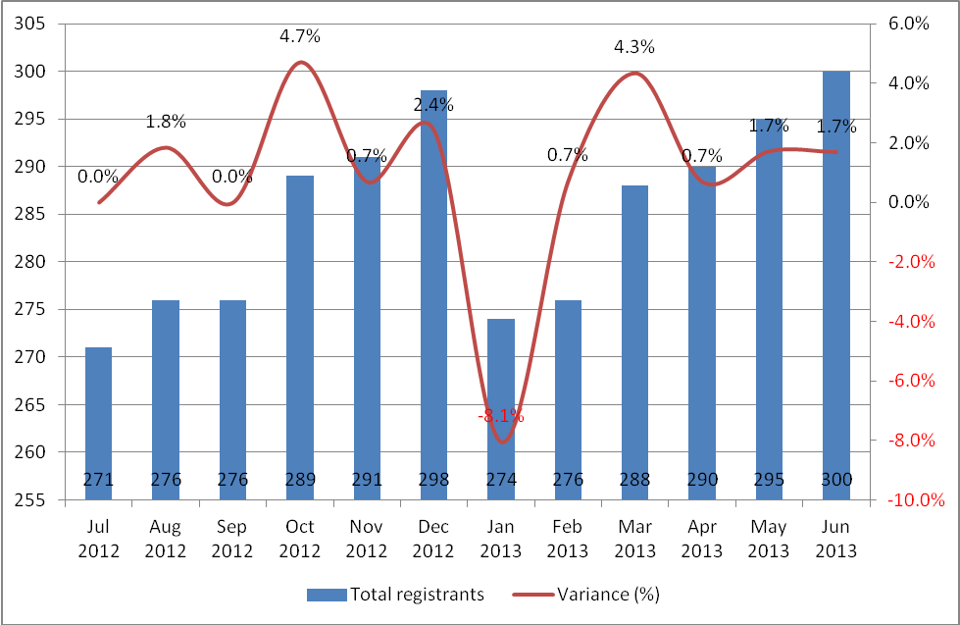
Overwhelmingly, registrants practice out of the Northern Territory, with 228 registrants nominating the NT as their principle place of practice (PPP). This represents 76 per cent of all registrants of this profession.
The number of registered Aboriginal and Torres Strait Islander health practitioners in other states and territories is illustrated in the graph below. Queensland hosts the second largest registrant base for this profession, with 10% of registrants nominating this state as their PPP. This is followed by New South Wales (7%), Western Australia (2%), and Victoria (2%). Encouraging growth for this new profession has occurred in both NSW and Queensland, which, 12 months ago, had only two and six registrants respectively. In comparison, by June 2013, 21 and 31 registrants nominated NSW and Queensland as their PPP.

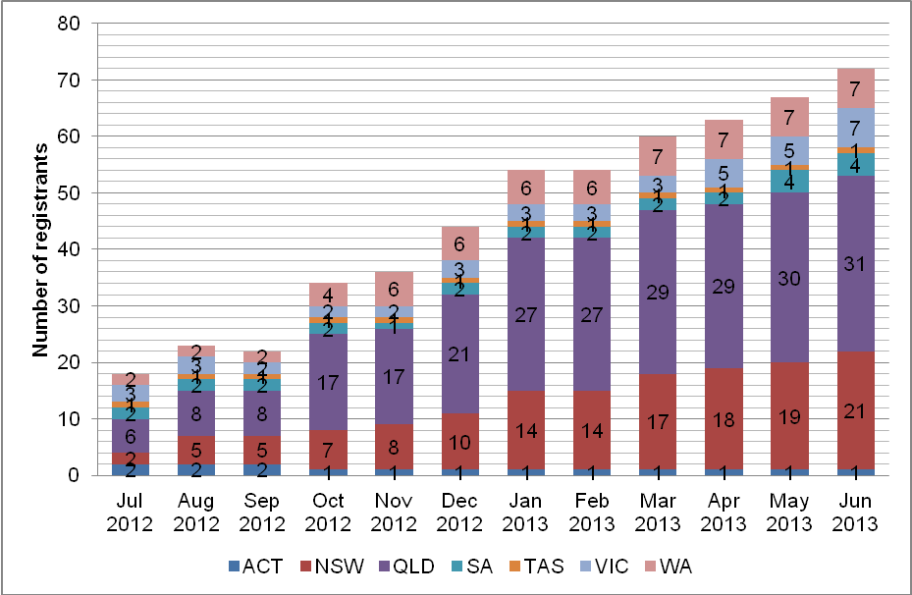

Overview of registration applications
At June 2013, a total of 117 applications for general registration had been received. Of these:
67 were granted registration
11 were incomplete
2 have been asked to ‘show cause’
17 were refused registration
13 were withdrawn, and
the rest are under consideration.
Below is an overview of the principle place of practice of registration applicants:
There has been an increase in the number of applicants from South Australia, all of whom have completed; or are going to complete; the Certificate IV in Aboriginal and/or Torres Strait Islander Primary Health Care (Practice). However significantly more applicants still originate in Queensland: accounting for 44% of all applications received.
No applications have yet been submitted by applicants with a PPP in Tasmania. One application has been received with a PPP in the Australian Capital Territory. The ‘other’ in the table above relates to applications made in error.
Of the 117 applications received, 74% have been from female applicants.
Who should be registered?
The Health Practitioner Regulation National Law, as in force in each state and territory (the National Law), requires a practitioner to be registered if they wish to, or their employer requires them to use one of the protected titles. The protected titles are:
- Aboriginal and Torres Strait Islander health practitioner
- Aboriginal health practitioner, or
- Torres Strait Islander health practitioner.
It is also the case that a practitioner may be required to be registered as part of their employment requirements, even if the protected title is not used.
The current wording implies that an employer must use a protected title for anyone performing the functions of an Aboriginal and Torres Strait Islander health practitioner. In fact, an employer may call a job anything they like, but if the employer requires the practitioner to hold registration as an Aboriginal and Torres Strait Islander health practitioner as a requirement of the job, the practitioner must be registered to be employed. While the employer’s requirements are not part of the National Law, it is another situation that may apply to a practitioner without using a protected title.
The Board's registration standards and application forms for registration as an Aboriginal and Torres Strait Islander health practitioner are available on the Board’s website at www.atsihealthpracticeboard.gov.au/Registration/Forms.
What is a condition on a health practitioner’s registration?
The Board, through its Registration and Notification Committee, can impose a condition on the registration of an Aboriginal and Torres Strait Islander health practitioner or student. A condition aims to restrict a practitioner’s practice in some way, to protect the public.
Current conditions which restrict a practitioner’s practice are published on the publicly available register of practitioners. When the Board decides the condition is no longer required to ensure safe practice, it is removed and no longer published on the register.
Examples of conditions include requiring the practitioner to:
- complete specified further education or training within a specified period
- undertake a specified period of supervised practice
- do, or refrain from doing, something in connection with the practitioner’s practice
- manage their practice in a specified way
- report to a specified person at specified times about the practitioner’s practice, or
- not employ, engage or recommend a specified person, or class of persons.
There may also be conditions related to a practitioner’s health (such as psychiatric care or drug screening). The details of health conditions are not usually published on the publicly available register of practitioners.
What is a notation on a health practitioner’s registration?
A notation records a limitation on the practice of a registrant. This is used by the Board to describe and explain the scope of a practitioner’s practice by noting the limitations on that practice. The notation does not change the practitioner’s scope of practice but may reflect the requirements of a registration standard.
Accreditation
The Aboriginal and Torres Strait Islander Health Practice Accreditation Committee released a consultation paper on the Accreditation standards and accreditation process for Aboriginal and Torres Strait Islander health practice. The public consultation closed on 6 September 2013.
After the consultation, the Board will consider the feedback provided and then finalise the accreditation standards. The Accreditation Committee will then use the approved accreditation standards to assess programs of study and the education providers that offer the programs to ensure that they produce graduates who have the knowledge, skills and professional attributes to competently practise the profession.
You can receive updates from the Accreditation Committee by completing the online form.
Jenny Poelina
Acting Chair, Aboriginal and Torres Strait Islander Health Practice Board of Australia

20 September 2013

