Communiqué

April 2013 meeting of the Aboriginal and Torres Strait Islander
Health Practice Board of Australia
Introduction
The Aboriginal and Torres Strait Islander Health Practice Board of Australia (the Board) works in partnership with the Australian Health Practitioner Regulation Agency (AHPRA) to implement the National Registration and Accreditation Scheme (the National Scheme).
Details on individual Board members can be found on the Board’s website.
Registration
Current registration figures
By the end of March 2013 there were 288 registered Aboriginal and Torres Strait Islander health practitioners throughout Australia. This is 4.3 per cent increase from the previous month, which had
276 registrants.
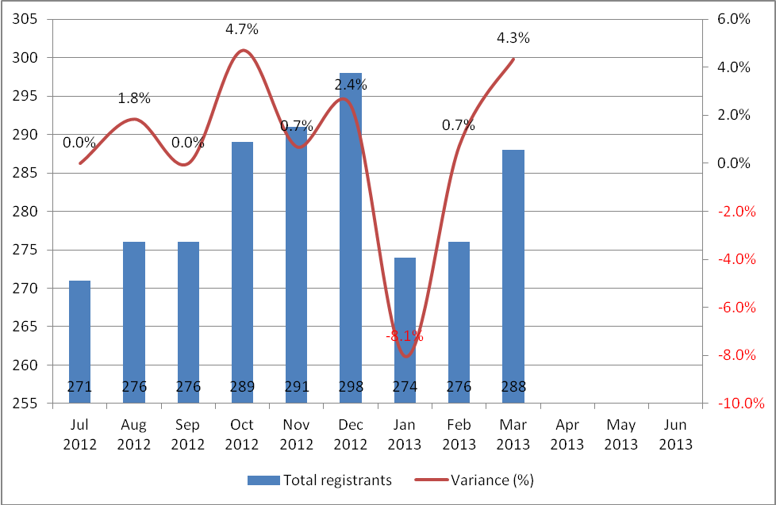
Overwhelmingly, registrants practice out of the Northern Territory, with 228 practitioners nominating the NT as their principle place of practice (PPP). This represents 79 per cent of all registrants of this profession.

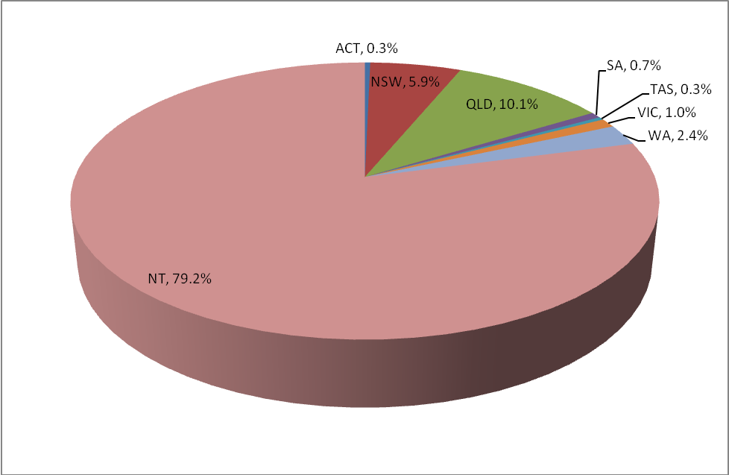

The number of registered Aboriginal and Torres Strait Islander health practitioners in other states and territories is illustrated in the graph below. Queensland hosts the second largest registrant base for this profession, with 10% of practitioners nominating this state as their principal place of practice.
This is followed by New South Wales (3%), Western Australia (2%), and Victoria (1%).

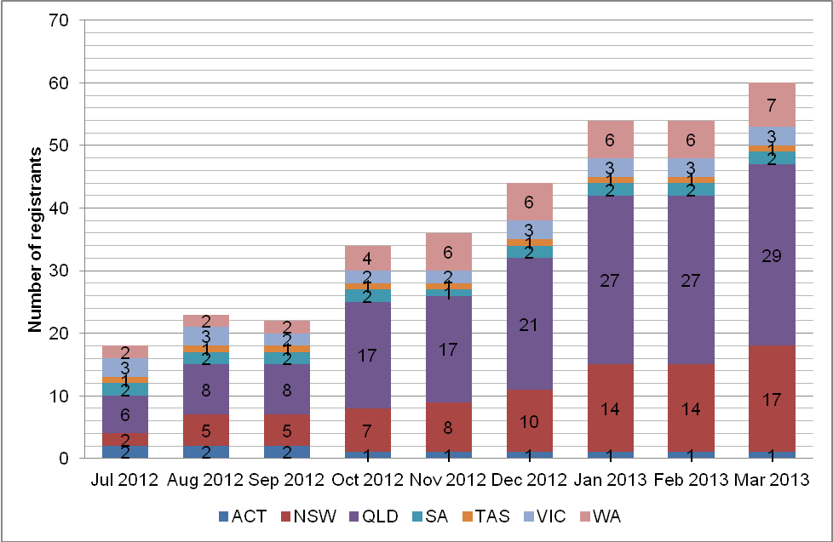
Who should be registered?
Only Aboriginal and Torres Strait Islander people who are working as Aboriginal and Torres Strait Islander health practitioners and are required by their employer to use any of the following protected titles, must be registered by law. This group also must meet the Board's registration standards in order to practise in Australia.
The protected titles are:
- Aboriginal and Torres Strait Islander health practitioner
- Aboriginal health practitioner, or
- Torres Strait Islander health practitioner.
Aboriginal and Torres Strait Islander health workers who are not required by their employer to use a protected title do not need to be registered, and can continue to work using their current titles (for example, ’sexual health worker’, or ’drug and alcohol worker’, or ’mental health worker’).
However, if an Aboriginal and Torres Strait Islander health worker’s job involves direct clinical care of patients, the Board highly recommends that they apply for registration in the interest of public safety. Registration is a way of ensuring that only health practitioners who are suitably trained and qualified to practise in a competent and ethical manner are registered.
Application forms for registration as an Aboriginal and Torres Strait Islander health practitioner are available on the Board’s website at www.atsihealthpracticeboard.gov.au/Registration/Forms.
Accreditation
The Accreditation Committee held a joint meeting with the Board on 24 April in Melbourne. This meeting enabled the Board and the Committee to discuss an early draft of the proposed accreditation standards and processes. The Committee is now making some final adjustments before presenting these draft standards and processes to key stakeholders for preliminary consultation. After analysing their feedback from the preliminary consultation process, the Committee will then present its draft standards and processes for wide-ranging public consultation. This stage is estimated to commence in September 2013.
Future joint meetings between the Committee and the Board will include a focus on monitoring and evaluating the agreed timelines for key milestones of this priority function.
Other Board activities
Board’s new bi-monthly meeting schedule for 2013/14 financial year
At its 24 April 2013 meeting, the Board agreed to move from a monthly to a bi-monthly meeting schedule – this means six Board and committee meetings per year instead of eleven. This new approach will allow the Board to further reduce its operating costs. Also, in response to stakeholder feedback, the Board has agreed to conduct its meetings in various capital cities throughout Australia. While the cost of interstate meetings are only marginally more than meeting in Melbourne, the opportunity to engage directly with current and potential registrants and their employers is expected to lead to increased registrations over time.
New gifts, benefits and hospitality policy
The Board adopted a new National boards’ gifts, benefits and hospitality policy at its 24 April 2013 meeting.
The policy outlines when it is appropriate to accept gifts, benefits or hospitality, when these should be declined, and how any acceptance should be managed by board members and the Board. The policy also offers guidance on hospitality being provided by the National Board to their members, committees, AHPRA employees or stakeholders.
The policy establishes a common understanding of appropriate conduct expected of all members of the Board and its committees in relation to the acceptance and provision of gifts, benefits and hospitality.
The newly adopted policy’s principles, which Board members must adhere to, are to:
- refuse all offers of gifts, benefits or hospitality that could be reasonably perceived as undermining their integrity and impartiality or that of the Board
- not accept for sole personal use gifts, benefits or hospitality from individuals or organisations about whom they are likely to exercise their functions under the National Law
- refuse all offers of money or items easily converted to money
- not solicit or accept gifts, benefits or hospitality that could reasonably be perceived as influencing them or their work with the Board, and
- immediately report to the Board, any attempt(s) to influence them or their duties under the National Law with gifts, benefits or hospitality.
Developing new supervision guidelines
The Board is in the process of developing new supervision guidelines. Establishing professional standards for this new profession is one of the Board’s core regulatory functions. When finalised and approved, these guidelines may be used as evidence of what constitutes appropriate professional conduct or practice for Aboriginal and Torres Strait Islander health practitioners in proceedings against a health practitioner under the National Law, or a law of a co-regulatory jurisdiction.
Once the final draft has been approved by the Board, the first step is for these guidelines to be presented to key stakeholders as part of our commitment to a preliminary consultation process. After analysing the preliminary feedback and considering if further refining is necessary, the next step is for these guidelines to be open to wide-ranging public consultation. The final steps will be to consider all the feedback, consider if further refining is necessary, and to approve the final version.
These guidelines are necessary for this new profession because some applications for registration have required a supervision report to validate the assertions by some registration applicants. As an interim measure, supervision reports used by the former Aboriginal Health Workers Board of the Northern Territory have been used for this purpose.
Current consultations
From time to time the Board seeks feedback from practitioners, members of the public and other stakeholders on proposed standards, guidelines, codes and policies. We encourage your active feedback on these proposals, so please keep a watch of the consultation section of Board’s website at www.atsihealthpracticeboard.gov.au/News/Consultations. Past consultations are also accessible from this section.
Peter Pangquee
Chairperson

24 May 2013

