

Aboriginal and Torres Strait Islander Health Practice Board of Australia

Registrant data

Reporting period: 1 October 2017 – 31 December 2017

Table of contents
Introduction 3
Principal place of practice 4
1. Registration type 4
2. Percentage 4
Age group 5
3. Registration type 5
Gender 6
4. Registration type 6
5. Percentage 6

Introduction
The functions of the Aboriginal and Torres Strait Islander Health Practice Board of Australia include:
- registering the Aboriginal and Torres Strait Islander Health Practitioners and students
- developing standards, codes and guidelines for the Aboriginal and Torres Strait Islander Health Practice profession
- handling notifications, complaints, investigations and disciplinary hearings, and
- approving accreditation standards and accredited courses of study.
The Board’s functions are supported by the Australian Health Practitioner Regulation Agency (AHPRA). For information about legislation governing our operations see AHPRA's Legislation & Publications at www.ahpra.gov.au/Publications
The Board has analysed its registration data and produced a number of statistical breakdowns about registrants to share with the profession and community. The Board shares these breakdowns regularly.
For more information on Aboriginal and Torres Strait Islander Health Practice registration, please see the Board’s website: www.atsihealthpracticeboard.gov.au/Registration

Principal place of practice
- Registration type
  - Registration type by principal place of practice
Registration type | ACT | NSW | NT | QLD | SA | TAS | VIC | WA | No PPP | Total
General | 3 | 126 | 218 | 117 | 47 | 3 | 20 | 109 |  | 643
Non-practising |  | 1 | 1 |  |  |  |  | 2 |  | 4
Total | 3 | 127 | 219 | 117 | 47 | 3 | 20 | 111 |  | 647

- Percentage
  - Percentage by principal place of practice
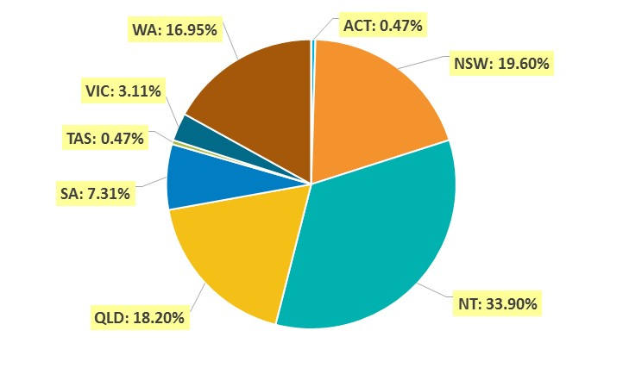

Age group
- Registration type
  - Registration type by age group
Age group | General | Non-practising | Total
U - 25 | 27 |  | 27
25 - 29 | 49 | 1 | 50
30 - 34 | 63 |  | 63
35 - 39 | 69 | 1 | 70
40 - 44 | 80 | 2 | 82
45 - 49 | 88 |  | 88
50 - 54 | 109 |  | 109
55 - 59 | 76 |  | 76
60 - 64 | 61 |  | 61
65 - 69 | 16 |  | 16
70 - 74 | 5 |  | 5
75 - 79
80+
Total | 643 | 4 | 647

  - Registrants by age group

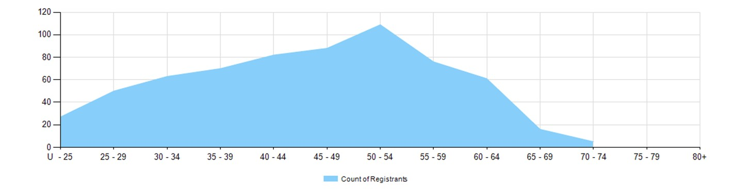

Gender
- Registration type
  - Registration type by gender
Gender | Registration type | ACT | NSW | NT | QLD | SA | TAS | VIC | WA | No PPP | Total
Female | General | 2 | 97 | 157 | 94 | 32 | 3 | 17 | 86 |  | 488
Female | Non-practising |  | 1 | 1 |  |  |  |  |  |  | 2
Total female |  | 2 | 98 | 158 | 94 | 32 | 3 | 17 | 86 |  | 490
Male | General | 1 | 29 | 61 | 23 | 15 |  | 3 | 23 |  | 155
Male | Non-practising |  |  |  |  |  |  |  | 2 |  | 2
Total male |  | 1 | 29 | 61 | 23 | 15 |  | 3 | 25 |  | 157
Total |  | 3 | 127 | 219 | 117 | 47 | 3 | 20 | 111 |  | 647

- Percentage
  - Percentage by gender
Registration type | ACT | NSW | NT | QLD | SA | TAS | VIC | WA | No PPP | Total
Female | 66.7% | 77.2% | 72.1% | 80.3% | 68.1% | 100.0% | 85.0% | 77.5% | .0% | 75.7%
Male | 33.3% | 22.8% | 27.9% | 19.7% | 31.9% | .0% | 15.0% | 22.5% | .0% | 24.3%

